WEB – SEMANTICS

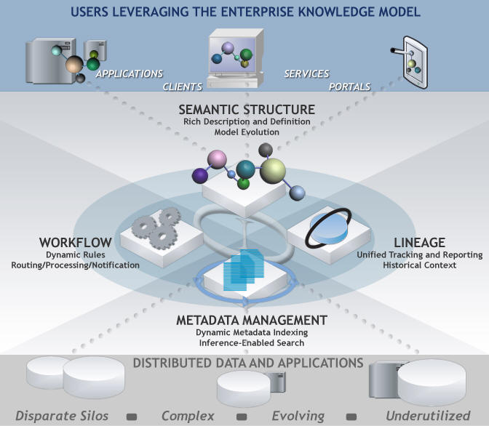
Armando Padilla
Ashok Sahu

A Report Submitted in Partial Fulfillment of the Requirements for cs537

Table of Contents

- Introduction 3
1.1 Today’s Web 3
1.2 From Today’s Web to the Semantic Web: Examples 5
1.2.1 Knowledge Management 5
1.2.2 Business-to-Consumer Electronic Commerce 7
1.2.3 Business-to-Business Electronic Commerce 8
1.2.4 Personal Agents: A Future Scenario 9
1.3 Semantic Web Technologies 10
1.3.1 Explicit Metadata 11
1.3.2 Ontologies 13
1.3.3 Logic 16
1.3.4 Agents 19
- Semantic Web: Current Status (Tools and Research) 22
2.1 Introduction 22
2.2 – Semantic Web Language: Building the idea with Resource Description Framework and the Web Ontology Language 25
2.2.1 – RDF: Why do we need it? 25
2.2.2 RDF: Statements 26
2.2.3 RDF: Syntax by Example 27
2.2.4 RDF: Validation and Tools 28
2.2.4.1 - BrownSauce 30
2.2.4.2 - IsaViz 30
2.2.4.3 - Jena 31
2.3 OWL: An Introduction Web Ontology Language (OWL) 31
2.3.1 OWL: The three flavors of OWL 32
2.3.2 OWL: Syntax by Example 33
2.3.3 – OWL: Validation and Tools 36
- Available Solutions for Web Semantics 37
3.1 A Task-Based Ontology Approach to Automate Geospatial Data Retrieval 37
3.2 Semantic Web Services Framework for Computational Mechanics 42
3.3 E-Tourism: Creating Dynamic Packages using Semantic Web Processes 45
- Semantic Web: Technology Issues 51
4.1 Trust in the Semantic Web 51
4.2 Semantic Web Agents 52
4.2 Ontology Representation 53
4.3 Non Technical Issues 54
4.4 Summary 54
- Future Trends 54
5.1 Knowledge Management 54
5.2 Dynamic Packaging Applications 55
5.3 Web Services Discovery and QOS-Aware extension 55
5.4 Semantic Knowledge Transparency in E-Business Processes 56

Introduction

1.1 Today’s Web
The World Wide Web has changed the way people communicate with each other and the way business is conducted. It lies at the heart of a revolution that is currently transforming the developed world toward a knowledge economy and, more broadly speaking, to a knowledge society.
This development has also changed the way we think of computers. Originally they were used for computing numerical calculations. Currently their predominant use is for information processing, typical applications being data bases, text processing, and games. At present there is a transition of focus towards the view of computers as entry points to the information highways.
Most of today’s Web content is suitable for human consumption. Even Web content that is generated automatically from databases is usually presented without the original structural information found in databases. Typical uses of the Web today involve people’s seeking and making use of information, searching for and getting in touch with other people, reviewing catalogs of online stores and ordering products by filling out forms, and viewing adult material.
These activities are not particularly well supported by software tools. Apart from the existence of links that establish connections between documents, the main valuable, indeed indispensable, tools are search engines.
Keyword-based search engines, such as AltaVista, Yahoo, and Google, are the main tools for using today’s Web. It is clear that the Web would not have been the huge success it was, were it not for search engines. However, there are serious problems associated with their use:

- High recall, low precision. Even if the main relevant pages are retrieved, they are of little use if another 28,758 mildly relevant or irrelevant documents were also retrieved. Too much can easily become as bad as too little.

- Low or no recall. Often it happens that we don’t get any answer for our request, or that important and relevant pages are not retrieved. Although low recall is a less frequent problem with current search engines, it does occur.

- Results are highly sensitive to vocabulary. Often our initial keywords do not get the results we want; in these cases the relevant documents use different terminology from the original query. This is unsatisfactory because semantically similar queries should return similar results.

- Results are single Web pages. If we need information that is spread over various documents, we must initiate several queries to collect the relevant documents, and then we must manually extract the partial information and put it together.
Interestingly, despite improvements in search engine technology, the difficulties remain essentially the same. It seems that the amount of Web content outpaces technological progress.
But even if a search is successful, it is the person who must browse selected documents to extract the information he is looking for. That is, there is not much support for retrieving the information, a very time-consuming activity. Therefore, the term information retrieval, used in association with search engines, is somewhat misleading; location finder might be a more appropriate term. Also, results of Web searches are not readily accessible by other software tools; search engines are often isolated applications.
The main obstacle to providing better support to Web users is that, at present, the meaning of Web content is not machine-accessible. Of course, there are tools that can retrieve texts, split them into parts, check the spelling, and count their words. But when it comes to interpreting sentences and extracting useful information for users, the capabilities of current software are still very limited. It is simply difficult to distinguish the meaning of
- I am a professor of computer science.
From
- I am a professor of computer science, you may think. Well, …
Using text processing, how can the current situation be improved? One solution is to use the content as it is represented today and to develop increasingly sophisticated techniques based on artificial intelligence and computational linguistics. This approach has been followed for some time now, but despite some advances the task still appears too ambitious.
An alternative approach is to represent Web content in a form that is more easily machine-process able and to use intelligent techniques to take advantage of these representations. We refer to this plan of revolutionizing the Web as the Semantic Web initiative. It is important to understand that the Semantic Web will not be a new global information highway parallel to the existing World Wide Web; instead it will gradually evolve out of the existing Web.
The Semantic Web is propagated by the World Wide Web Consortium (W3C), an international standardization body for the Web. The driving force of the Semantic Web initiative is Tim Berners-Lee, the very person who invented the WWW in the late 1980s. He expects from this initiative the realization of his original vision of the Web, a vision where the meaning of information played a far more important role than it does in today’s Web.
The development of the Semantic Web has a lot of industry momentum, and governments are investing heavily. The U.S. government has established the DARPA Agent Markup Language (DAML) Project, and the Semantic Web is among the key action lines of the European Union’s Sixth Framework Program.

1.2 From Today’s Web to the Semantic Web: Examples

1.2.1 Knowledge Management
Knowledge management concerns itself with acquiring, accessing, and maintaining knowledge within an organization. It has emerged as a key activity of large businesses because they view internal knowledge as an intellectual asset from which they can draw greater productivity, create new value, and increase their competitiveness. Knowledge management is particularly important for international organizations with geographically dispersed departments.
Most information is currently available in a weakly structured form, for example, text, audio, and video. From the knowledge management perspective, the current technology suffers from limitations in the following areas:
- Searching information. Companies usually depend on keyword-based search engines, the limitations of which we have outlined.
- Extracting information. Human time and effort are required to browse the retrieved documents for relevant information. Current intelligent agents are unable to carry out this task in a satisfactory fashion.
- Maintaining information. Currently there are problems, such as inconsistencies in terminology and failure to remove outdated information.
- Uncovering information. New knowledge implicitly existing in corporate databases is extracted using data mining. However, this task is still difficult for distributed, weakly structured collections of documents.
- Viewing information. Often it is desirable to restrict access to certain information to certain groups of employees. “Views”, which hide certain information, are known from the area of databases but are hard to realize over an intranet (or the Web).
The aim of the Semantic Web is to allow much more advanced knowledge management systems:
- Knowledge will be organized in conceptual spaces according to its meaning.
- Automated tools will support maintenance by checking for inconsistencies and extracting new knowledge.
- Keyword-based search will be replaced by query answering: requested knowledge will be retrieved, extracted, and presented in a human-friendly way.
- Query answering over several documents will be supported.
- Defining who may view certain parts of information (even parts of documents) will be possible.

1.2.2 Business-to-Consumer Electronic Commerce
Business-to-consumer (B2C) electronic commerce is the predominant commercial experience of Web users. A typical scenario involves a user’s visiting one or several online shops, browsing their offers, selecting and ordering products.
Ideally, a user would collect information about prices, terms, and conditions (such as availability) of all, or at least all major, online shops and then proceed to select the best offer. But manual browsing is too time-consuming to be conducted on this scale. Typically a user will visit one or a very few online stores before making a decision.
To alleviate this situation, tools for shopping around on the Web are available in the form of shopbots, software agents that visit several shops, extract product and price information, and compile a market overview. Their functionality is provided by wrappers, programs that extract information from an online store. One wrapper per store must be developed. This approach suffers from several drawbacks.
The information is extracted from the online store site through keyword search and other means of textual analysis. This process makes use of assumptions about the proximity of certain pieces of information (for example, the price is indicated by the word price followed by the symbol $ followed by a positive number). This heuristic approach is error-prone; it is not always guaranteed to work. Because of these difficulties only limited information is extracted. For example, shipping expenses, delivery times, restrictions on the destination country, level of security, and privacy policies are typically not extracted. But all these factors may be significant for the user’s decision making. In addition, programming wrappers is time-consuming, and changes in the online store outfit require costly reprogramming.
The Semantic Web will allow the development of software agents that can interpret the product information and the terms of service.
- Pricing and product information will be extracted correctly, and delivery and privacy policies will be interpreted and compared to the user requirements.
- Additional information about the reputation of online shops will be retrieved from other sources, for example, independent rating agencies or consumer bodies.
- The low-level programming of wrappers will become obsolete.
- More sophisticated shopping agents will be able to conduct automated negotiations, on the buyer’s behalf, with shop agents.

1.2.3 Business-to-Business Electronic Commerce
Most users associate the commercial part of the Web with B2C e-commerce, but the greatest economic promise of all online technologies lies in the area of business-to-business (B2B) e-commerce.
Traditionally businesses have exchanged their data using the Electronic Data Interchange (EDI) approach. However this technology is complicated and understood only by experts. It is difficult to program and maintain, and it is error-prone. Each B2B communication requires separate programming, so such communications are costly. Finally, EDI is an isolated technology. The interchanged data cannot be easily integrated with other business applications.
The Internet appears to be an ideal infrastructure for business-to-business communication. Businesses have increasingly been looking at Internet-based solutions, and new business models such as B2B portals have emerged. Still, B2B e-commerce is hampered by the lack of standards. HTML (hypertext markup language) is too weak to support the outlined activities effectively: it provides neither the structure nor the semantics of information. The new standard of XML is a big improvement but can still support communications only in cases where there is a priori agreement on the vocabulary to be used and on its meaning.
The realization of the Semantic Web will allow businesses to enter partnerships without much overhead. Differences in terminology will be resolved using standard abstract domain models, and data will be interchanged using translation services. Auctioning, negotiations, and drafting contracts will be carried out automatically (or semi automatically) by software agents.

1.2.4 Personal Agents: A Future Scenario
Michael had just had a minor car accident and was feeling some neck pain. His primary care physician suggested a series of physical therapy sessions. Michael asked his Semantic Web agent to work out some possibilities.
The agent retrieved details of the recommended therapy from the doctor’s agent and looked up the list of therapists maintained by Michael’s health insurance company. The agent checked for those located within a radius of 10 km from Michael’s office or home, and looked up their reputation according to trusted rating services. Then it tried to match available appointment times with Michael’s calendar. In a few minutes the agent returned two proposals. Unfortunately, Michael was not happy with either of them. One therapist had offered appointments in two weeks’ time; for the other Michael would have to drive during rush hour. Therefore, Michael decided to set stricter time constraints and asked the agent to try again.
A few minutes later the agent came back with an alternative: A therapist with an excellent reputation who had available appointments starting in two days. However, there were a few minor problems. Some of Michael’s less important work appointments would have to be rescheduled. The agent offered to make arrangements if this solution were adopted. Also, the therapist was not listed on the insurer’s site because he charged more than the insurer’s maximum coverage. The agent had found his name from an independent list of therapists and had already checked that Michael was entitled to the insurer’s maximum coverage, according to the insurer’s policy. It had also negotiated with the therapist’s agent a special discount. The therapist had only recently decided to charge more than average and was keen to find new patients.
Michael was happy with the recommendation because he would have to pay only a few dollars extra. However, because he had installed the Semantic Web agent a few days ago, he asked it for explanations of some of its assertions: how was the therapist’s reputation established, why was it necessary for Michael to reschedule some of his work appointments, how was the price negotiation conducted? The agent provided appropriate information.
Michael was satisfied. His new Semantic Web agent was going to make his busy life easier. He asked the agent to take all necessary steps to finalize the task.

1.3 Semantic Web Technologies
The scenarios outlined in section 1.2 are not science fiction; they do not require revolutionary scientific progress to be achieved. We can reasonably claim that the challenge is an engineering and technology adoption rather than a scientific one: partial solutions to all important parts of the problem exist. At present, the greatest needs are in the areas of integration, standardization, development of tools, and adoption by users. But, of course, further technological progress will lead to a more advanced Semantic Web than can, in principle, be achieved today.
In the following sections we outline a few technologies that are necessary for achieving the functionalities previously outlined.

1.3.1 Explicit Metadata
Currently, Web content is formatted for human readers rather than programs. HTML is the predominant language in which Web pages are written (directly or using tools). A portion of a typical Web page of a physical therapist might look like this:
<h1>Agilitas Physiotherapy Centre</h1>
Welcome to the home page of the Agilitas Physiotherapy Centre.
Do you feel pain? Have you had an injury? Let our staff
Lisa Davenport, Kelly Townsend (our lovely secretary)
and Steve Matthews take care of your body and soul.

<h2>Consultation hours</h2>
Mon 11am - 7pm<br>
Tue 11am - 7pm<br>
Wed 3pm - 7pm<br>
Thu 11am - 7pm<br>
Fri 11am - 3pm<p>
But note that we do not offer consultation
during the weeks of the
<a href=". . .">State Of Origin</a> games.
For people the information is presented in a satisfactory way, but machines will have their problems. Keyword-based searches will identify the words physiotherapy and consultation hours. And an intelligent agent might even be able to identify the personnel of the center. But it will have trouble distinguishing therapists from the secretary, and even more trouble with finding the exact consultation hours (for which it would have to follow the link to the State Of Origin games to find when they take place).
The Semantic Web approach to solving these problems is not the development of super intelligent agents. Instead it proposes to attack the problem from the Web page side. If HTML is replaced by more appropriate languages, then the Web pages could carry their content on their sleeve. In addition to containing formatting information aimed at producing a document for human readers, they could contain information about their content. In our example, there might be information such as
<company>
<treatmentOffered>Physiotherapy</treatmentOffered>
<companyName>Agilitas Physiotherapy Centre</companyName>
<staff>
<therapist>Lisa Davenport</therapist>
<therapist>Steve Matthews</therapist>
<secretary>Kelly Townsend</secretary>
</staff>
</company>
This representation is far more easily processable by machines. The term metadata refers to such information: data about data. Metadata capture part of the meaning of data, thus the term semantic in Semantic Web.
In our example scenarios in section 1.2 there seemed to be no barriers in the access to information in Web pages: therapy details, calendars and appointments, prices and product descriptions, it seemed like all this information could be directly retrieved from existing Web content. But, as we explained, this will not happen using text-based manipulation of information but rather by taking advantage of machine-processable metadata.
As with the current development of Web pages, users will not have to be computer science experts to develop Web pages; they will be able to use tools for this purpose. Still, the question remains why users should care, why they should abandon HTML for Semantic Web languages. Perhaps we can give an optimistic answer if we compare the situation today to the beginnings of the Web. The first users decided to adopt HTML because it had been adopted as a standard and they were expecting benefits from being early adopters. Others followed when more and better Web tools became available. And soon HTML was a universally accepted standard.
Similarly, we are currently observing the early adoption of XML. While not sufficient in itself for the realization of the Semantic Web vision, XML is an important first step. Early users, perhaps some large organizations interested in knowledge management and B2B e-commerce, will adopt XML and RDF, the current Semantic Web-related W3C standards. And the momentum will lead to more and more tool vendors’ and end users’ adopting the technology.
This will be a decisive step in the Semantic Web venture, but it is also a challenge. As we mentioned, the greatest current challenge is not scientific but rather one of technology adoption.

1.3.2 Ontologies
The term ontology originates from philosophy. In that context, it is used as the name of a subfield of philosophy, namely, the study of the nature of existence (the literal translation of the Greek word Oντoλoγiα), the branch of metaphysics concerned with identifying, in the most general terms, the kinds of things that actually exist, and how to describe them. For example, the observation that the world is made up of specific objects that can be grouped into abstract classes based on shared properties is a typical ontological commitment.
However, in more recent years, ontology has become one of the many words hijacked by computer science and given a specific technical meaning that is rather different from the original one. Instead of “ontology” we now speak of “an ontology”. For our purposes, we will use T.R. Gruber’s definition, later refined by R. Studer: An ontology is an explicit and formal specification of a conceptualization.
In general, an ontology describes formally a domain of discourse. Typically, an ontology consists of a finite list of terms and the relationships between these terms. The terms denote important concepts (classes of objects) of the domain. For example, in a university setting, staff members, students, courses, lecture theaters, and disciplines are some important concepts.
The relationships typically include hierarchies of classes. A hierarchy specifies a class C to be a subclass of another class C′ if every object in C is also included in C′. For example, all faculty are staff members. Figure 1.1 shows a hierarchy for the university domain.

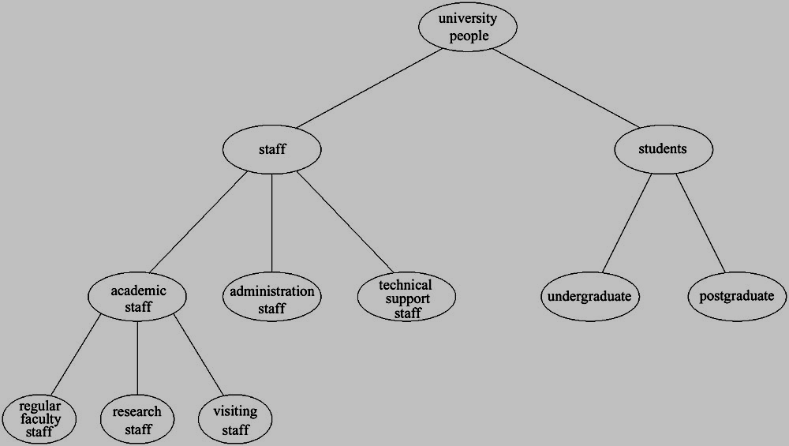
Figure 1.1: A hierarchy
Apart from subclass relationships, ontologies may include information such as
- properties (X teaches Y)
- value restrictions (only faculty members can teach courses)
- disjointness statements (faculty and general staff are disjoint)
- specification of logical relationships between objects (every department must include at least ten faculty members)
In the context of the Web, ontologies provide a shared understanding of a domain. Such a shared understanding is necessary to overcome differences in terminology. One application’s zip code may be the same as another application’s area code. Another problem is that two applications may use the same term with different meanings. In university A, a course may refer to a degree (like computer science), while in university B it may mean a single subject (CS 101). Such differences can be overcome by mapping the particular terminology to a shared ontology or by defining direct mappings between the ontologies. In either case, it is easy to see that ontologies support semantic interoperability.
Ontologies are useful for the organization and navigation of Web sites. Many Web sites today expose on the left-hand side of the page the top levels of a concept hierarchy of terms. The user may click on one of them to expand the subcategories.
Also, ontologies are useful for improving the accuracy of Web searches. The search engines can look for pages that refer to a precise concept in an ontology instead of collecting all pages in which certain, generally ambiguous, keywords occur. In this way, differences in terminology between Web pages and the queries can be overcome.
In addition, Web searches can exploit generalization/specialization information. If a query fails to find any relevant documents, the search engine may suggest to the user a more general query. It is even conceivable for the engine to run such queries proactively to reduce the reaction time in case the user adopts a suggestion. Or if too many answers are retrieved, the search engine may suggest to the user some specializations.
In Artificial Intelligence (AI) there is a long tradition of developing and using ontology languages. It is a foundation Semantic Web research can build upon. At present, the most important ontology languages for the Web are the following:
- XML provides a surface syntax for structured documents but imposes no semantic constraints on the meaning of these documents.
- XML Schema is a language for restricting the structure of XML documents.
- RDF is a data model for objects (“resources”) and relations between them; it provides a simple semantics for this data model; and these data models can be represented in an XML syntax.
- RDF Schema is a vocabulary description language for describing properties and classes of RDF resources, with a semantics for generalization hierarchies of such properties and classes.
- OWL is a richer vocabulary description language for describing properties and classes, such as relations between classes (e.g., disjointness), cardinality (e.g. “exactly one”), equality, richer typing of properties, characteristics of properties (e.g., symmetry), and enumerated classes.

1.3.3 Logic
Logic is the discipline that studies the principles of reasoning; it goes back to Aristotle. In general, logic offers, first, formal languages for expressing knowledge. Second, logic provides us with well-understood formal semantics: in most logics, the meaning of sentences is defined without the need to operationalize the knowledge. Often we speak of declarative knowledge: we describe what holds without caring about how it can be deduced.
And third, automated reasoners can deduce (infer) conclusions from the given knowledge, thus making implicit knowledge explicit. Such reasoners have been studied extensively in AI. Here is an example of an inference. Suppose we know that all professors are faculty members, that all faculty members are staff members, and that Michael is a professor. In predicate logic the information is expressed as follows:
- prof(X) → faculty(X)
- faculty(X) → staff(X)
- prof(michael)
Then we can deduce the following:
- faculty(michael)
- staff(michael)
- prof(X) → staff(X)
Note that this example involves knowledge typically found in ontologies. Thus logic can be used to uncover ontological knowledge that is implicitly given. By doing so, it can also help uncover unexpected relationships and inconsistencies.
But logic is more general than ontologies. It can also be used by intelligent agents for making decisions and selecting courses of action. For example, a shop agent may decide to grant a discount to a customer based on the rule
where the loyalty of customers is determined from data stored in the corporate database. Generally there is a trade-off between expressive power and computational efficiency. The more expressive a logic is, the more computationally expensive it becomes to draw conclusions. And drawing certain conclusions may become impossible if non computability barriers are encountered. Luckily, most knowledge relevant to the Semantic Web seems to be of a relatively restricted form. For example, our previous examples involved rules of the form, “If conditions, then conclusion,” and only finitely many objects needed to be considered. This subset of logic is tractable and is supported by efficient reasoning tools.
An important advantage of logic is that it can provide explanations for conclusions: the series of inference steps can be retraced. Moreover AI researchers have developed ways of presenting an explanation in a human-friendly way, by organizing a proof as a natural deduction and by grouping a number of low-level inference steps into metasteps that a person will typically consider a single proof step. Ultimately an explanation will trace an answer back to a given set of facts and the inference rules used.
Explanations are important for the Semantic Web because they increase users’ confidence in Semantic Web agents (see the physiotherapy example in section 1.2.4). Tim Berners-Lee speaks of an “Oh yeah?” button that would ask for an explanation.
Explanations will also be necessary for activities between agents. While some agents will be able to draw logical conclusions, others will only have the capability to validate proofs, that is, to check whether a claim made by another agent is substantiated. Here is a simple example. Suppose agent 1, representing an online shop, sends a message “You owe me $80” (not in natural language, of course, but in a formal, machine-processable language) to agent 2, representing a person. Then agent 2 might ask for an explanation, and agent 1 might respond with a sequence of the form
Web log of a purchase over $80
Proof of delivery (for example, tracking number of UPS)
Rule from the shop’s terms and conditions:
- purchase(X, Item) price(Item, Price) delivered(Item, X) → owes(X, Price)
Thus facts will typically be traced to some Web addresses (the trust of which will be verifiable by agents), and the rules may be a part of a shared commerce ontology or the policy of the online shop.
For logic to be useful on the Web it must be usable in conjunction with other data, and it must be machine-processable as well. Therefore, there is ongoing work on representing logical knowledge and proofs in Web languages. Initial approaches work at the level of XML, but in the future rules and proofs will need to be represented at the level of RDF and ontology languages, such as DAML+OIL and OWL.

1.3.4 Agents
Agents are pieces of software that work autonomously and proactively. Conceptually they evolved out of the concepts of object-oriented programming and component-based software development.
A personal agent on the Semantic Web (figure 1.2) will receive some tasks and preferences from the person, seek information from Web sources, communicate with other agents, compare information about user requirements and preferences, select certain choices, and give answers to the user. An example of such an agent is Michael’s private agent in the physiotherapy example of section 1.2.4.?
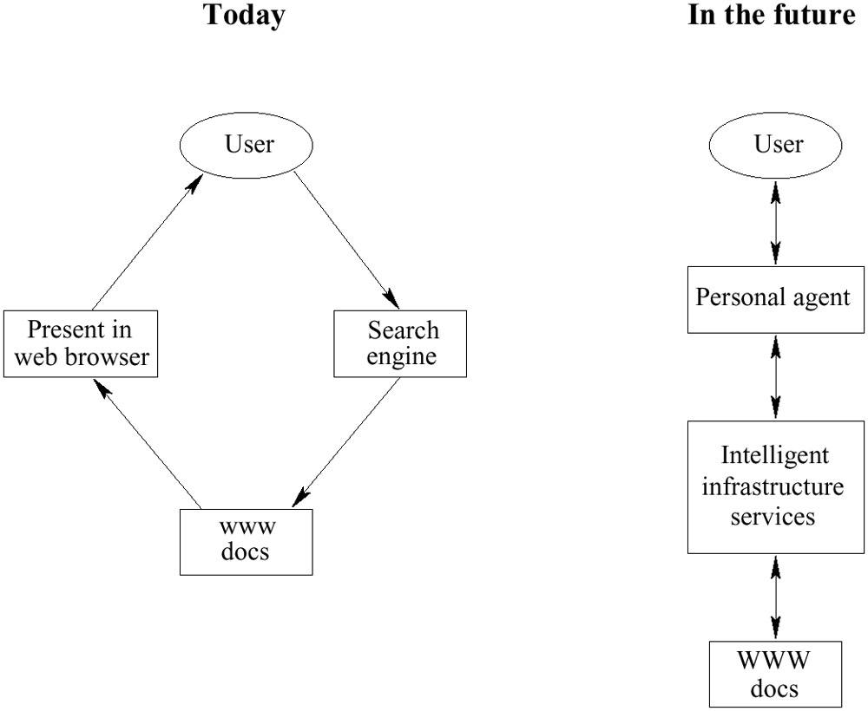
Figure 1.2: Intelligent personal agents
It should be noted that agents will not replace human users on the Semantic Web, nor will they necessarily make decisions. In many, if not most, cases their role will be to collect and organize information, and present choices for the users to select from, as Michael’s personal agent did in offering a selection between the two best solutions it could find, or as a travel agent does that looks for travel offers to fit a person’s given preferences.
Semantic Web agents will make use of all the technologies we have outlined:
- Metadata will be used to identify and extract information from Web sources.
- Ontologies will be used to assist in Web searches, to interpret retrieved information, and to communicate with other agents.
- Logic will be used for processing retrieved information and for drawing conclusions.
Further technologies will also be needed, such as agent communication languages. Also, for advanced applications it will be useful to represent formally the beliefs, desires, and intentions of agents, and to create and maintain user models.

Semantic Web: Current Status (Tools and Research)

2.1 Introduction
To understand what tools are available and what research has been done in the field of the Semantic Web we have to reference Figure 2.1 and look at the different technologies that make up the Semantic Web.

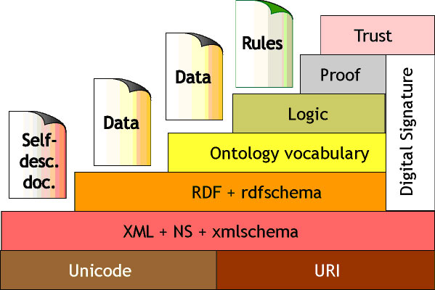
Figure 2.1

By referencing Figure 2.1 it’s clear that the Semantic Web is not a simple language nor a simple application we can use one type of technology to get it started and working. Since the Semantic Web requires different technologies; such as RDF, OWL, XML+NS, to work together there should be a broad range of tools to use. Unfortunately, the primary technologies in use for the “Self Description Document” sections of Figure 2.1, the layers we will be focusing on, are few.

What tools are available for each of the different layers the Semantic Web has? And, What is the current forefront research being made in the area of the Semantic Web? This section will cover not only these questions but also provide current examples for RDF and OWL, which are leading tools in creating the Semantic Web, along with, providing background on the most up-to-date research currently being conducted for the Semantic Web. Before we delve into details regarding the underlying technologies like OWL and RDF, we would like to give an introduction to XML and URI.

XML
One of the fundamental contributions towards the Semantic Web to date has been the development of XML itself. Liberating data from opaque, inextensible formats as it does, XML provides an interoperable syntactical foundation upon which solutions to the larger issues of representing relationships and meaning can be built. It's an important center of agreement among individual developers and corporations. The face of the Web is changing, offering once again new possibilities for communication and interaction -- not because all of the underlying concepts are new per se, but because they can be combined on the Web and exposed to the opportunity and unpredictability of large-scale decentralization.

XML supplements presentation markup with markup that provides a context for understanding the meaning of the data, for example, <author>Berners-Lee</author>. The advantage of XML is that software programs can read the specialized tags and perform operations such as extracting bibliographic information
The structure, content, and semantics of XML documents are defined in an associated Document Type Definition (DTD) file or in an XML Schema. XML Schemas express shared vocabularies and provide a means for defining the structure, content, and semantics of XML documents. These schemas formalize the syntax and value constraints of XML instances and facilitate the sharing of information among communities of users
XML namespaces enable the combination, in a single XML document, of element (and sometimes attribute) names from more than one XML vocabulary. Namespaces address some of the semantic blending problems that exist in a Semantic Web (Brooks, 2002). Namespaces are useful when XML documents pull data from multiple XML sources and encounter element name collisions. However, XML namespaces are unable to solve the more serious semantic problem that stems from the rarity of precise agreement about the meaning of any common word.
Another important aspect of XML is XHTML, the extensible hypertext markup language. As noted earlier, HTML was designed to display data while XML was designed to describe data. The W3C defines XHTML as the latest version of HTML, with the goal of gradually replacing HTML. XHTML is almost identical to HTML 4.01, and is in fact HTML 4.01 rewritten to follow XML rules. XHTML combines all the elements of HTML 4.01 with the syntax of XML. XHTML forces designers to write “well-formed” documents that work in all browsers and that are backward compatible with older browsers and will soon play a larger role in the Semantic Web.
XSLT (extensible stylesheet language transformations) is a language for transforming an XML document into another XML document, or into another type of document that is recognized by a browser, like HTML and XHTML.

URI
A URI is simply a Web identifier, like the strings starting with http or ftp that you often see on the World Wide Web. Anyone can create a URI, and the ownership of URIs is clearly delegated, so they form an ideal base technology on top of which to build a global Web. In fact, the World Wide Web is such a thing: anything that has a URI is considered to be "on the Web." Every data object and every data schema/model in the Semantic Web must have a unique URI.

A Uniform Resource Locator (URL) is a URI that, in addition to identifying a resource, provides a means of acting upon or obtaining a representation of that resource by describing its primary access mechanism or network location. For example, the URL http://www.webifysolutions.com is a URI that identifies a resource (Webify Solutions' home page) and implies that a representation of that resource (such as the home page's current HTML code, as encoded characters) is obtainable through HTTP from a network host named ww.webifysolutions.com.

A Uniform Resource Name (URN) is a URI that identifies a resource by name in a particular namespace. You can use a URN to talk about a resource without implying its location or how to dereference it. For example, the URN urn:ISBN:1-0-7666-98-0 is a URI that, like an ISBN book number, allows one to talk about a book, but doesn't suggest where and how to obtain an actual copy of it.
Uniform resource identifiers (URIs) provide another foundation of the Semantic Web (Berners-Lee & Miller, 2002). A URI is much like a URL, but it does not have to map to a real Web address. Further, a URI can represent concepts (e.g., “author”), living entities (e.g., “Tim Berners-Lee”), and virtually anything else (Rhyno, 2002). URIs can even point to physical entities, which means that the RDF language can be used to describe devices such as cell phones and TVs, which can, in turn “advertise their functionality — what they can do and how they are controlled — much like software agents” (Berners-Lee et al., 2001, p. 43). Groups can declare their specialized concepts in terms of URIs, and these concepts, in turn, can be related (broader, narrower, synonymous, and so forth). Thus, URI’s provide the capability to uniquely identify not only resources, but also can indicate the relationships among resources.

2.2 – Semantic Web Language: Building the idea with Resource Description Framework and the Web Ontology Language

2.2.1 – RDF: Why do we need it?
With vast amounts of data on the Internet today we typically use Google, Yahoo, or any of the many search engines to locate important information for us. A typical use of these companies’ service would go something like this. The user types in the phrase, “chair”, into the input field of the search engine and then watches as a display of hundreds, thousands, and possibly millions of results appear onto the screen. Here lies the problem; the keyword “chair” would not only display the most popular chairs, which a person can sit on, but also an organization’s chairs, the person that manages an organization.
The goal of RDF as a tool for the Semantic Web is to place published content under the appropriate context so such events do not occur.

The first RDF draft was released in 1997 by Ora Lassila and Ralph Swick and later released the first recommended RDF specification in 1999 located here, http://www.w3.org/RDF/. Currently RDF is maintained by the RDF Issue Tracking document and updates can be located at the RDF Interest Groups web site, , http://www.w3.org/RDF/Interest/.

2.2.2 RDF: Statements
RDF is based on the XML markup language and uses Namespaces. Using these technologies a person must create a set of statements, which contain three key items, a subject, predicate, and a value, {subject, property/predicate, value}.

A statement contains a unique identifier for the document or object the statement will describe, this is held in the “subject” area of the statement and usually is a unique-id of an object or the full URI of a online document. The predicate in the statement contains property information such as ‘name’,‘color’,’author’, etc, and the “value” section contains the value of the property given to the unique object. A simple RDF statement using a published online document could look like this, {http://www.armando.ws/rdf_example.html, author, Armando Padilla}

2.2.3 RDF: Syntax by Example
Along with using a set of statements to describe a document we use XML+NS to create the document. Using a simplified example of a DVD collection we can create a list of RDF/XML list to share a DVD collection with friends or the general public. We will need a base to start off with and we will also need a list of DVD’s to format into a RDF listing. By using a list of 2 DVD’s we can show the structure of a RDF list and validate it using an online RDF validation tool.

The initial step in creating an RDF document for this example is creating a list of properties as we would use when describing a DVD. A DVD has a title, director, a length of time, and our personal rating on scale of 1 though 10.

DVD_1 has a title of Gladiator.
DVD_1 has a director named XYZ
DVD_1 has a length of 90 minutes.
DVD_1 has a rating of 8
DVD_2 has a title of Lord of the Rings
DVD_2 has a director named XYZ
DVD_2 has a length of 65 minutes.
DVD_2 has rating of 5
Figure 2.2

Using the example described in Figure 2.2 we create the formatted statements shown in Figure 2.3.
{DVD_1, title, Gladiator}
{DVD_1, director, XYZ}
{DVD_1, length, 90m}
{DVD_1, rating, 8}
{DVD_2, title, Lord of the Rings}
{DVD_2, director, XYZ}
{DVD_2, length 90m}
{DVD_2, rating, 5}
Figure 2.3
Following this step, which is normally not required, we create our RDF document using XML+NS. Since we are using the RDF markup language we must use the namespace of “rdf” for out XML tags and begin each new element with a “Description” RDF type,
<rdf:Description>. Using the attribute “about” for the Description tag we specify the unique identifier for document RDF will describe. In this example were using the DVD Id. Next we create our own namespace, “mydvd” and begin to describe our DVD set using the same property names as we used in the predicate RDF Triple Figure 2.3.Our final RDF document will look like the Figure 2.4.

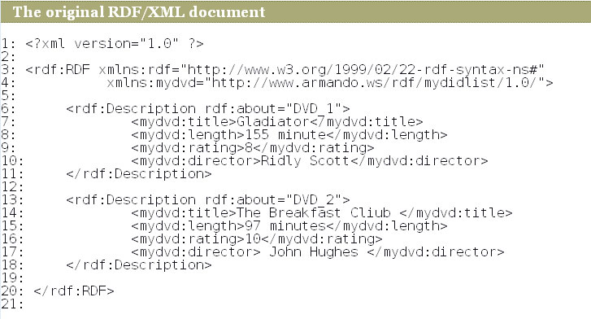
Figure 2.4: Complete RDF Example File. (Display Provided by http://www.w3.org/RDF/Validator/)

2.2.4 RDF: Validation and Tools
The semantic web could be a collection of RDF document that are not valid or flaws syntax, for this reason there are open source validators and IDE’s that a developer can use.

The World Wide Web Consortium has created a RDF validator, which can be located at this location, http://www.w3.org/RDF/Validator/. The validator provides two methods that the user can point to their created RDF document. One method is via a text-area that the user can copy and paste their RDF document and another method is by specifying a full URL to the RDF document published on the web.

If the document validation passes the user has additional options on how they would like to have the data displayed. Two methods of display are either through a triple and/or a graph as seen both Figures 2.5 and 2.6

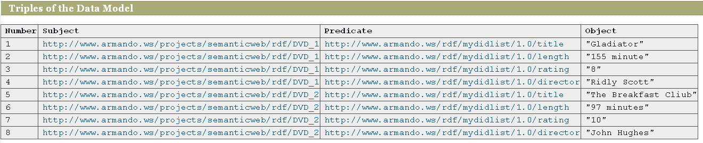
Figure 2.7 RDF DVD file in Triples. (Display Provided by http://www.w3.org/RDF/Validator/)

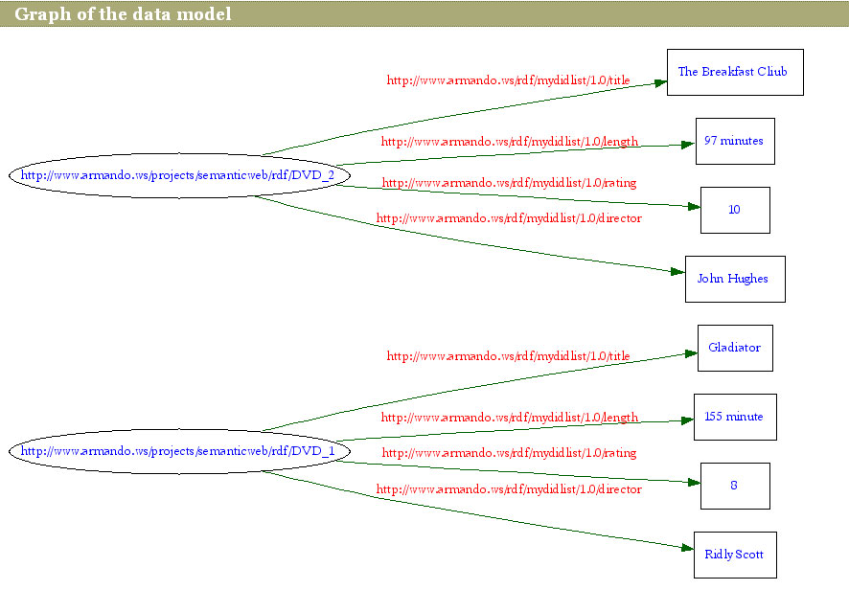
Figure 2.6 RDF DVD Example as Graph (Display Provided by http://www.w3.org/RDF/Validator/)

2.2.4.1 - BrownSauce
Viewing a RDF document can also be made using other tools available on the web. One of the browsers in use at the moment is BrownSauce. BrownSauce can be downloaded at the current location, http://brownsauce.sourceforge.net/. BrownSauce was created by the HP Labs and released under the BSD style license.

2.2.4.2 - IsaViz
Another tool for visualizing an RDF document comes from the same inventor of BrownSauce and allows users to visualize RDF documents as graphs. IsaViz is a standalone tool, which allows users to create RDF documents in a IDE tool setting. IsaViz is free for downloading at http://www.w3.org/2001/11/IsaViz/.

2.2.4.3 - Jena
Jena is an open source semantic web framework for Java developers created by HP Labs and can be downloaded at http://jena.sourceforge.net/. Jena allows developers to utilize the RDF API, read RDF documents, create N3 and N-Triple formatted documents, it also contains an OWL API and contains a SPARQL engine. More information can be found on the web site. http://jena.sourceforge.net/

2.3 OWL: An Introduction Web Ontology Language (OWL)
RDF is not the only markup language that is used as a tool for the Semantic Web. Using an ontology language, the Web Ontology Language, can enhance RDF. Research into the Web Ontology Language was initially done using DAML, the DARPA Markup Language and then branched out into the Web Ontology Language (OWL) in 2001 when the Web Ontology Working Group launched an extensive definition to create anthologies on the web. OWL enhances RDF by adding additional restrictions and additional information concerning the RDF document. With OWL the user can create objects, add cardinality rules, use unions, and much more.

What is OWL? The World Wide Web Consortium OWL Overview documentation puts it in this way,

“OWL facilitates greater machine interpretability of Web content than that supported by XML, RDF, and RDF Schema (RDF-S) by providing additional vocabulary along with a formal semantics”
- OWL Web Ontology Language Overview

In other words, OWL allows RDF to place additional restrictions on statements. Using the previous DVD rating list example we can use OWL to place restrictions on the DVD list by placing restrictions such as; “DVD_1 is a DVD object” and “DVD is a type of Media”.

2.3.1 OWL: The three flavors of OWL
Unlike RDF, OWL has been broken up into three versions, OWL Lite, OWL DL and OWL Full. OWL Lite, like the other two editions is based on XML but unlike the other two editions OWL Lite only uses cardinalities of 0 and 1 and keeps its implementation to a minimum. OWL DL, or OWL Description Logics, contains all the OWL support but, according to the specification, “many of the constructs can only be used under specific situations”. The last edition, OWL Full allows developers to use the entire OWL support that OWL Lite and OWL DL contains. The overall structure and hierarchy of OWL is described in Figure 2.7.
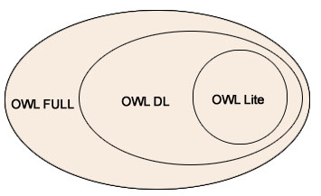
Figure 2.7

As Figure 2.7 describes, OWL Full is a combination of OWL DL and OWL Lite. While OWL DL cannot process items that OWL Full contains but contains and can process OWL Lite format. To gain further details concerning OWL syntax or for general information the World Wide Web Consortium has created a web site located at, http://www.w3.org/TR/owl-features/ .

2.3.2 OWL: Syntax by Example
Continuing with our initial RDF document shown in Figure 2.4 we will expand the example to use OWL Lite. Since much of OWL is written using XML, XML rules have to be followed along with the given RDF rules. Using OWL we can create objects, create a subtype of a class, and add properties for out document. We will create a, Media, object, a, DVD object, and add the appropriate properties to the DVD object, covering the Class, subClassOf, and the ObjectProperty to start.

Constructing our document we load the DTD file located at, http://www.w3.org/2002/07/owl#, and create out initial object, Media. Using the Class tag we set the name of the class by using the attribute “rdf:ID”, <owl:Class rdf:ID="Media" /> . The next step is to create a subclass of Media. Since a DVD is a type of class we can associate the DVD object as a subclass of the Media class by using the “subClassOf, reference,
<owl:Class rdf:ID="DVD" >
<rdf:subClassOf rdf:resource="#Media" />
</owl:Class>
OWL also allows developers to add properties to a class. For our example a DVD contains four properties, “title”, “rating”, “length”, and director. Placing these properties into the DVD object using the ObjectProperty attribute. Since the engine does not know where the property belongs we use the domain attribute to specify that the properties for the DVD belong to the DVD object. Our initial document can be seen in Figure 2.8
<?xml version="1.0" ?>
<rdf:RDF xmlns:rdf="http://www.w3.org/1999/02/22-rdf-syntax-ns#"
xmlns:mydvd="http://www.armando.ws/rdf/mydidlist/1.0/"
xmlns:owl ="http://www.w3.org/2002/07/owl#">

<owl:Ontology rdf:about="http://www.armando.ws/rdf/mydidlist/">
<owl:versionInfo>1.0</owl:versionInfo>
</owl:Ontology>
<owl:Class rdf:ID="Media" />
<owl:Class rdf:ID="DVD" >
<rdf:subClassOf rdf:resource="#Media" />
<rdf:label xml:lang="en">Armando's DVD Ratings</rdf:label>
</owl:Class>
<owl:ObjectProperty rdf:ID="title">
<rdf:domain rdf:resource="#DVD" />
</owl:ObjectProperty>
<owl:ObjectProperty rdf:ID="movie_length">
<rdf:domain rdf:resource="#DVD" />
</owl:ObjectProperty>
<owl:ObjectProperty rdf:ID="rating">
<rdf:domain rdf:resource="#DVD" />
</owl:ObjectProperty>
<owl:ObjectProperty rdf:ID="movie_director">
<rdf:domain rdf:resource="#DVD" />
</owl:ObjectProperty>
Figure 2.8

Adding information concerning our DVDs can now be done by referencing the documents objects and properties. The DVD’s, Gladiator and the Breakfast Club are types of DVD objects we use the <DVD> tag and set the ID to the unique identifier for each DVD. In the case of Gladiator we use the unique identifier of, “DVD_1”. Adding information into the DVD’s object property we leave the tag DVD open and enter in tags with the given name of the tag to be the property name.
<DVD rdf:ID="DVD_1" >
<title rdf:resource="Gladiator" />
<rating rdf:resource="8" />
<movie_length rdf:resource="155" />
</DVD>

The value is represented as the value inside the resource namespace.. The final OWL RDF document can be seen in figure 2.9 Additional information and features can be located at the OWL reference home page, http://www.w3.org/TR/owl-xmlsyntax/apd-example.html

<?xml version="1.0" ?>

<rdf:RDF xmlns:rdf="http://www.w3.org/1999/02/22-rdf-syntax-ns#"
xmlns:mydvd="http://www.armando.ws/rdf/mydidlist/1.0/"
xmlns:owl ="http://www.w3.org/2002/07/owl#">

<owl:Ontology rdf:about="http://www.armando.ws/rdf/mydidlist/">
<owl:comment>Armando's DVD rating List</owl:comment>
<owl:versionInfo>1.0</owl:versionInfo>
</owl:Ontology>

<owl:Class rdf:ID="Media" />
<owl:Class rdf:ID="DVD" >
<rdf:subClassOf rdf:resource="#Media" />
<rdf:label xml:lang="en">Armando's DVD Ratings</rdf:label>
</owl:Class>

<owl:ObjectProperty rdf:ID="title">
<rdf:domain rdf:resource="#DVD" />
</owl:ObjectProperty>

<owl:ObjectProperty rdf:ID="movie_length">
<rdf:domain rdf:resource="#DVD" />
</owl:ObjectProperty>

<owl:ObjectProperty rdf:ID="rating">
<rdf:domain rdf:resource="#DVD" />
</owl:ObjectProperty>

<owl:ObjectProperty rdf:ID="movie_director">
<rdf:domain rdf:resource="#DVD" />
</owl:ObjectProperty>

<DVD rdf:ID="DVD_1" >
<title rdf:resource="Gladiator" />
<rating rdf:resource="8" />
<movie_length rdf:resource="155" />
</DVD>

</rdf:RDF>

2.3.3 – OWL: Validation and Tools
With OWL containing much of RDF markup in its document RDF validation application can be used to validate a OWL document. This section will cover the IDEs and the browsers that the Semantic Web community has created for OWL, such as Protégé and SMORE.

Protégé
Protégé is an open source Java based IDE which allows users to model ontologies. According to the online resource, Protégé can also be extended to build knowledge-based tools and applications by extending it with a Java based API. Protégé also provides two methods to model ontologies, Protégé-Frames and Protégé-OWL. Protégé-Frames allows users to create and edit ontologies, which are frame-based while Protégé-OWL allows users to create OWL documents for the Semantic Web. Additional information can be located on the Protégé web site, http://protege.stanford.edu/

OWL Lite/Owl Full/OWL DL Checker
One of the main troubles with OWL is determining what type of document the developer has created in terms of OWL markup versions. An online tool has been created to help the user determine resolve such an issue. The online tool is located at, http://www.mygrid.org.uk/OWL/Validator. To use the tool the user copies and pastes the document in question into a specified input field and then clicks on the button on the to validate and determine the type of document.

SMORE
The Semantic Markup, Ontology and RDF Editor is an open source project created to allow users to create OWL based ontologies for any given online web page using a IDE such as Protégé. According to the web site some of the features SMORE contains is a way to copy and paste web content, a OWL validator, anda built in ontology browser, SWOOP. Additional information can be found on the SMORE’s web site, http://www.mindswap.org/2005/SMORE/

Available Solutions for Web Semantics

3.1 A Task-Based Ontology Approach to Automate Geospatial Data Retrieval
Spatial Databases are used for representing spatial data about geographical features such as mountains, cities, roads, and locations and other spatial objects such as VLSI layouts. These are examples of 2-dimensional spatial data. Spatial data can also be 3- dimensional as in the case of data representing the earth's topography and solid objects (as in CAD).
Spatial databases facilitate, for example, the building of store locators such as the ones provided by many businesses on their websites. They also facilitate the building of "yellow page" searches. Suppose a customer wants to find an Everest Books store. The customer can do this by using a store locator, if one is provided by Everest Books on its website, or by using a yellow pages search provided by a web service such as
Database systems that support the building of spatial databases provide special data types, called geometry or geographic types, to define spatial objects. In addition, they provide facilities to store, retrieve, query, and manipulate spatial data. They also support the definition of spatial indexes to speed up the retrieval, querying, and manipulation of spatial data.
Spatial database facilities are not part of standard SQL specifications. Nevertheless, many databases, including MySQL, support SQL extensions for manipulating spatial objects, that is, they provide facilities for storing, retrieving, and querying spatial objects. Examples of spatial objects are
- points,
- lines,
- rectangles,
- polygons, and
- curves.
Spatial extensions defined in SQL also provide facilities for determining the relationship between objects, for example, whether or not
- one object touches another,
- two objects intersect, or
- one object is contained in another.

Geospatial data is collected and formulated by many agencies, primarily government related agencies. They help in emergency scenarios such as disaster recovery, information gathering, land improvement projects etc. Since the amount of data being produced is so large, potential users may still have difficulty searching for geospatial data sources over the Web due to not knowing where data are stored. As a result, many data seekers use a general Internet search engine to search for geospatial data. Better methods are needed for effective search and dissemination of geospatial data. Below is a comparison between current portals and task based ontology.

Current Portal Design | Task-based ontology system
Limited data source organization | Additional level of data source organization  using task-based information
Limited use of values in metadata  fields to locate data | Uses metadata values along with a  task-oriented approach based on ontology  restrictions and rules
Uses bounding box coordinates  to locate data | Uses a place ontology with synonyms,  region names, and explicit relationships  to data sources
Uses a relational DBMS to store  and search metadata in a  straightforward manner | Uses an enhanced system with ontologies,  rules, deductive reasoning, and a general  knowledge base
Architecture for task-based searching
Data Providers
USER

Domain Experts
Task-based Search GUII
RULE
ENGINE
ONTOLOGIES
DATA Sources + Tasks
Knowledge Base
calls
Returns Results
Wiki
Convert to OWL
Access

The above figure is a diagram showing how users, data providers and domain experts interact with the task-based search application.
Users, shown in the upper left-hand corner, access the task-based search application to search for geospatial data. Using the GUI, the user selects the type of task and enters the location involved. As explained further , the application then calls the rule engine, which inferences over a knowledge base using rules having specifications for a metadata search. The rules are generically written with variables (i.e. parameterized) such that new values for task type and location can be substituted on each execution. Once metadata files describing appropriate data for the task are found and processed, the URLs of the data sources are extracted and output as a search result.

Data providers, shown in the upper right-hand corner, supply the data needed by
the user and the associated descriptive metadata. Our system uses metadata characteristics such as theme, currency, precision, and accuracy, in addition to location information, to determine whether or not a data set is appropriate for a task.

Domain experts, shown in the bottom left-hand corner of the diagram, are valuable in developing the knowledge base to determine the types of data sets and characteristics needed for particular tasks. To expand our current knowledge base, we have started to experiment with a collaborative process using Wiki technology in which experts assign types of data sources, such as “road data” or “land use data” to types of tasks such as “fire emergency response” or “flood response”. This information informs the pre-established restricted relationships in the knowledge base. The domain experts also specify more complex requirements for geospatial restrictions, such as accuracy. This information is used to form the rules that inference over metadata.

We use the description logic modeling power of OWL DL to restrict the types of data sources needed for each type of task. In OWL, a property restriction is a type of class description that describes an anonymous class by placing constraints on the class extension (the set of individuals associated with the class). Property restrictions can specify value or cardinality constraints and be applied to datatype or object properties. Here, to restrict the types of data sources needed for each type of task, we use the OWL “someValuesFrom” value constraint applied to an object property. For example, the following formal statement restricts the types of data needed for a fire response task to only include roads, land cover and hydrography: “needs (RoadData U
LandCoverData U HydrographyData)”. This places a restriction on the “needs” object property between the task class and the data source class states that
all values for this restricted relationship must be of a type listed and not of other types. The following OWL notation uses the “someValuesFrom” constraint to place the restriction.
{property restrictions on an anonymous subclass}
<owl:Class rdf:ID= “FireEmergencyResponse”>
<rdfs:subClassOf rdf:resource= “#IncidentManagement”/>
<rdfs:subClassOf>
{anonymous subclass}
<owl:Restriction>
{restrict to need roads, etc}
<owl:onProperty rdf:resource= “needs”/>
<owl:someValuesFrom rdf:resource= “#RoadData”/>
<owl:someValuesFrom rdf:resource= “#LandCoverData”/>
. . .
{other restrictions}
</owl:Restriction>
</rdfs:subClassOf>
</owl:Class>

Discussion
We intended to maximize the use of inherent modeling capabilities within OWL, such as levels of subclassing and someValuesFrom restrictions, to avoid hard-coding criteria in rules or queries as much as possible. That is, the value of establishing a full ontology with relationships and restrictions is to fully record, within the ontology itself, all the needed information. Then, instance data can be declared as being of multiple subclasses, and basic inference over inherent type information (using subsumption) would determine result sets. This is sufficient and functional in our application to the extent of finding, for example, a data source of type road and also of type shapefile.

However, when using OWL to further describe geospatial data, a variety of shortcomings become apparent. Geospatial data, in particular, need multiple selection criteria, including those on numerical categories. It can become unwieldy to declare numerous corresponding subclasses. Also, subclasses declared for numerical properties may have artificial ranges, e.g. verticalAccuracy 1mTo5m. For geospatial data, comparison operators
(e.g. verticalAccuracy < 5) are more practical, especially because different types of geospatial data can be described by characteristics such as attribute accuracy, spatial accuracy, pixel resolution, and scale, and the range of acceptable values will vary greatly depending upon the task for which the data are used. Instead of only using the inferencing capabilities of an OWL reasoner, we needed to incorporate the use of rules. The use of rules enables multiple criteria and comparisons, but then less ontological information is stored. In the end, we kept the association between tasks and data sources within the ontology but used rules to filter further metadata criteria.

3.2 Semantic Web Services Framework for Computational Mechanics

Introducing Semantic Web Services
Semantic Web Services, the idea of augmenting Web service descriptions using Semantic Web technology were introduced to address this kind of problem and to facilitate the autonomous publication, discovery, and execution of services at the semantic level. Semantic Web service description languages, such as OWL-S _OWL-S 2003_ and Web Service Modeling Ontology _WSMO_ _Roman et al. 2005_, were proposed as abstractions of syntactic Web service description languages such as WSDL, which are used in the present Web Services technology. They are meant to be used with semantic matchmakers, which are the software agents that accept and keep track of the descriptions of available services from providers and match them against the requirements from service consumers _Burstein et al. 2005_. Matchmakers enhance the role of UDDI service registries in the Semantic Web Services architecture. OWL-S is among the most widely used semantic Web service description languages and was submitted to W3C for possible standardization _Martin et al. 2004_. It describes the categories, the inputs, the outputs, and the consequences of Web services in terms of concepts defined in OWL ontologies. It also provides the grounding constructs for specialization into WSDL constructs for compatibility with existing Web services, which are described by WSDL documents. OWL-S is used as the semantic Web service description language in this research.

How Semantic Web Services Work
To illustrate how Semantic Web Services can help the program looking for the GetSineValue Web service to get the correct value of sine from the TrigonometricSine Web service, consider the OWL-S description of GetSineValue in OWL-S service profile description. below. The “service profile” description, which is the proposed information for use by matchmakers (Sycara et al. 2003), is presented.
<rdf:RDF>
<service:Service rdf:ID=”GetSineValueService”>
<service:presents rdf:resource=”#GetSineValureServiceProfile” />
</service:Service>

<profileHierararchy:SineFunctionEvaluator rdf:ID=”GetSineValueServiceProfile”>
<service:isPresentedBy rdf:resource=”#GetSineValureServiceProfile” />

<profile:hasInput>
<process:Input>
<process:parametertype
rdf:resource=”http://std.swscm.org/200407/quantities.owl/AngularDegree”
</process:Input>
</profile:hasInput>

<profile:hasEffect rdf:resource=
“http://std.swscm.org/200407/MathOperationEffects.owl/ TrigonometricFunctionValueEffect”/>

<profile:hasOutput>
<process:UnConditionalOutput>
<process:parameterType
rdf:resource=“http://std.swscm.org/200407/quantities.owl/UnaryConstantFunctionQuantity” />
</process:UnConditionalOutput>
</profile:hasOutput>
</ profileHierararchy:SineFunctionEvaluator>
</rdf:RDF>

The OWL-S specification. above shows that:
1. The GetSineValueService which is the service that the program is looking for is a kind of SineFunctionEvaluator defined in the profileHierarchy taxonomy;
2. The service takes one input parameter “Angular Degree” the definition of which is available at
<http://std.swscm.org/200407/quantities.owl/AngularDegree>, and gives one output the definition of which is available at <http://std.swscm.org/200407/quantities.owl/UnaryConstantFunctionQuantity> and
3.The effect of this service is defined by http://std.swscm.org/200407/MathOperationEffects.owl/ TrigonometricFunctionValueEffect
In the Semantic Web Services architecture, when a service consumer needs a service from a provider, it creates an ideal service profile, such as the one in Fig. 4, and submits it to a matchmaker as a request for recommendation (Sycara et al. 2003). From the profiles registered by various service providers, the matchmaker would select the one that most closely matches the ideal profile requested, and recommend it to the consumer for further binding between the two parties. As the matchmaker processes the request, suppose that it had searched the list of service profiles advertised by service providers but could not find any service that perfectly matches. However, there is a TrigonometricSine Web service that advertises itself as a kind of SineFunctionEvaluator which gives a Unary-ConstantFunctionQuantity output and the TrigonometricFunctionValueEffect effect. Nevertheless, the service takes the input parameter defined by <http://www.math.org/terms.owl/RadianAngle> rather than the <http://std.swscm.org/200407/quantities.owl/AngularDegree>. If there are some assertions that the “radian angle” and the “angular degree” concepts are related in some ways, for example:
1. Both “radian angle” and “angular degree” are subclasses of <http://www.math.org/terms.owl/PlaneAngle>; and
2. The “angular degree” “has conversion factor” of pi /180 and “has reference unit of measurement” of <http://www.math.org/terms.owl/RadianAngle>.
By populating these assertions into the knowledge base of an inference engine, and by querying whether the pairs of service types, input parameters, output parameters, and effects, subsume each other Sycara et al. 2003, the matchmaker will be able to determine that the two Web services near perfectly match, and could thus recommend this TrigonometricSine Web service to the consumer. The consumer will be able to use the “has conversion factor” assertion to convert its angular degree into the radian angle unit expected by the service provider, and will be able to initiate a request to the TrigonometricSine Web service and finally get the correct sine function value.

3.3 E-Tourism: Creating Dynamic Packages using Semantic Web Processes
Dynamic Packaging Applications
Currently travelers must visit manually multiple independent Web sites to plan their trip, register their personal information multiple times, spend hours or days waiting for response or confirmation, and make multiple payments by credit card. Consumers are discouraged with the lack of functionality. They are demanding the ability to create, manage and update itineraries. With dynamic packaging technology, travelers can build customized trips that combine customer preferences with flights, car rentals, hotel, and leisure activities in a single price.
A dynamic packaging application allows consumers or travel agents to bundle trip components. These systems permit the customer to specify a set of preferences for a vacation, for example a five-day stay at the Madeira island, and dynamically access and query a set of information sources to find component such as air fairs, car rental, and leisure activities in real time

Dynamic Packaging System Architecture
The architecture to develop a dynamic packaging infrastructure has four major phases: integration of e-Tourism information sources, semantic mediator generation, dynamic packaging process generation, and dynamic packaging final products. All the components that are used in each phase are illustrated in Figure 1. Due to space limitation, we will only briefly describe each phase.
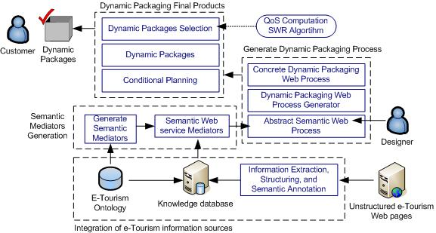

Integration of e-Tourism information sources
One big challenge to develop dynamic packaging applications is to find a solution to cope and integrate the non-standard way of defining e-tourism products and services. There are no standards or common criteria to express transportation vehicles, leisure activities, and weather conditions when planning for a vacation package, several ways can be found among all the existing Web sites. To deal with the lack of standard and enable data integration we rely on the use of ontologies and semantic annotation. As it has been recognized, the semantic Web can considerably improve e-Tourism.

Lack of standards
After studying several travel, leisure, and transportation online sites, we found out the lack of standards in the tourism domain. Some of the differences founded among sev-eral sites are the following:
The price of tourism related activities and services are expressed in many dif-ferent currencies (euros, dollars, British pounds, etc.)
The time units do not follow a standard. Some Web sites state time in hours, others in minutes, others in hours and minutes...etc. For example, 1 hour and 30 minutes, 1h and 30 min, 1:30 h, 90 min, one hour and thirty minutes, ninety minutes, 1:30 pm, etc.
The keywords used to express a date are not expressed in a normalized way. Some Web sites express a day of the week using the words Monday, Tues-day,..., Sunday, while other use the keywords M, T, ..., Su.
The temperature unit scale is not standard. It can be expressed in degrees centigrade as well as in degrees Celsius.

Our objective is find a solution to surpass this lack of standards in the tourism field by automatically understanding the different ways of expressing tourism products and services, extracting its relevant information and structuring. We argue that sophisti-cated technologies, such as semantics and ontologies, are good candidates to enable the development of dynamic packaging information systems.

E-Tourism Ontology
The e-Tourism ontology provides a way of viewing the world of tourism. It organ-izes tourism related information and concepts. The ontology will allow achieving interoperability through the use of a shared vocabulary and meanings for terms with respect to other terms.
In an early stage , a partial ontology for the e-Tourism was created using Protégé and the OWL language. This was a very time-consuming task since it was necessary to find out information about real tourism activities and infrastructures on the Web and feed them into the knowledge base. A partial view of e-Tourism ontology developed using Protégé is illustrated in Figure below. It should be noticed that this is a work in progress; the ontology is not complete yet. New concepts are being developed for its taxonomy and new axioms.

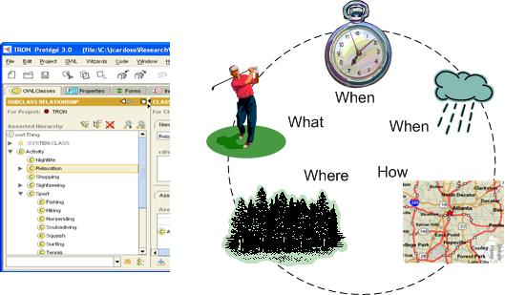

Semantic Mediators Generation
In our architecture, semantic mediators support a virtual view that integrates several e-Tourism information sources semantically annotated. Each mediator does not store any data and provide the system with uniform access to various e-Tourism information sources.
Mediators are automatically generated based on the e-Tourism ontology. Mediators are interrelated and form a hierarchical structure that is derived directly from the tax-onomy of the e-Tourism ontology.
To better explain these concepts, let us consider the partial taxonomy retrieved from our e-Tourism ontology illustrated in Figure below. From this particular taxonomy, the following set of semantic mediators is automatically generated:

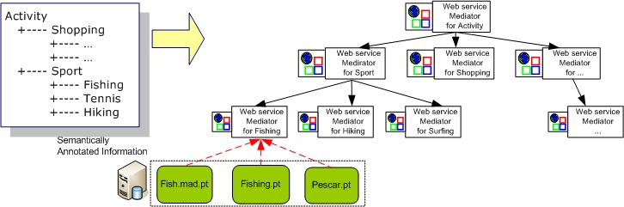

Each mediator gathers and integrates semantic information from its children. In this structure, the leaves are records of information coming from e-Tourism data sources which were semantically annotated.

Generate Dynamic Package Processes
The objective of this phase is to construct a set of processes that are able to compose valid dynamic packaging solutions for customers. This phase includes the following elements:

- Abstract semantic Web process
- Dynamic Packaging Web Process Generator
- Concrete Dynamic Packaging Web Process

Abstract Web process.
An abstract Web process specifies the control-flow and data-flow of an application, but does not define which Web services will be executed at runtime. Abstracting away the resource descriptions allows Web processes model-ing dynamic packages to be portable and reused to generate different process instance at runtime.
For example, Figure below shows an abstract Web process designed to construct a dy-namic package that includes a fishing experience in the morning, takes the tourist for shopping, schedules a golf game or a movie in the afternoon, and a dinner at night
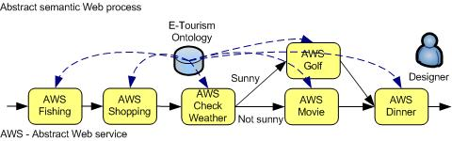

Dynamic Packaging Web Process Generator. Concrete dynamic package Web processes are automatically created using a suitable generator. In this step, the genera-tor may optimize the concrete process based on the availability of Web services. Each service in the abstract Web process is turned into an executable service by specifying the locations of the Web service implementation.

Concrete Dynamic Packaging Web Process. An abstract Web process typically originates several concrete processes. Each Web process invokes different Web ser-vices. At this point, the processes are valid from a functional point-of-view, but they may not generate valid dynamic package due, for example, to time or cost constraints.

Dynamic Packaging Products
Final dynamic package processes are created using conditional planning, ranking, and selection. We envisage using a conditional planning approach to allow the generation of correct dynamic packages. The main objective of the planning is to schedule an appropriate timeframe during which the tourist will realize a particular activity refer-enced by a dynamic package.
After using conditional planning, all the dynamic packages are valid. Nevertheless, some packages may take more time to execute than others or be more expensive for the tourist, i.e. they have a distinct QoS (Quality of Service). For these reasons the next phase is responsible for ranking and selecting the packages which have a set of characteristics that is more similar with the tourist requirements. To compute the QoS of each package process, we use the SWR algorithm . Once dynamic package processes are evaluated, they are presented to the tourist. Finally, the tourist can select the package that he finds more appealing or suitable according to his preferences.

4.0 Semantic Web: Technology Issues
Achieving the concept behind the Semantic Web is no easy task. Aside from the creation of the tools and validators the Semantic Web has introduce more questions and issues. How can the user trust that the information presented and mined is accurate and trust worthy? How will agents mine the data and properly present the information when updates occur? And most importantly how can users adopt this technology seamlessly?

4.1 Trust in the Semantic Web
One of the most prominent issues that the Semantic Web faces deals with the actual data that the Semantic Web uses. Given the many users of the World Wide Web, the simplicity of creating an ontology, and publishing its contents; the danger of publishing miss-guided information and content written by un-qualified individual is a possibility that faces the Semantic Web.

According to, Kalfoglou , Harith Alani, et al., one of the issues that will arise in the Semantic Web is the issue of using published documents created and maintained by un-qualified individuals. The example used was an example dealing with the context of the subject matter of a co-worker that’s an expert in proposals, yet lousy with cars, providing you advice on your car troubles. In other words, If a user of the Semantic Web used a service to find solutions to some of his/her automotive issues, the user would trust the mined data coming from an automotive expert rather than a master chef that does not have any engineering of automotive experience at all.

The example provided was a minor example which only affected one individual but what if the user wanted a remedy for a headache but the Semantic Web presented the user with the a lethal remedy written by a prankster.

A few attempts in the Semantic Web community are being made to place a security on this layer. Research has focused on proposing certification for the user and the data that has been published. For example, a Semantic Web agent once it has located the resource that it needs will check for a certification, much like a browser looks for an SSL certification on a https URL. If the agent validates that the certificate is valid the agent will go continue with its task but this security framework also contains issues such as spoofing of certificates and the verification that the author of the content is qualified to write it.

4.2 Semantic Web Agents
Semantic Web agents also add to the issues the Semantic Web faces. A Semantic Web Agent is a software that finds available data on the World Wide Web. The agent is usually built by the service provider and is one of the tools that is used to retrieve data from other sources.

A main issue that arises when dealing with Agents in the Semantic Web is how they represent data internally when provided a given source of information. Do to the way an agent is created, each agent represents the information it mines differently than another agents. Given this scenario, if two agents were to use the same data and require each other to share the information how could the Semantic Web work if one agent represented the meaning of the data in the current context differently than the other agent.

Another issue which arises while using agents is transparency. Transparency on what the agent is doing internally is a major issue that according to Kalfoglou point as a trust issue as well. An agent’s internal process must be available to the user that will receive the information in order to determine that the agent has not provided the user with inappropriate or misguided information. An example of such an issue can be represented by a user looking for stock market quotes using a semantic web service. The user believes that the agent for the service will mine the most valuable data for the specified stock symbol but what really occurs is the agent displaying predefined data specified by a company which lowers the stock value of the stock the user defined.

4.2 Ontology Representation
Representation of ontologoies is also a technical issue that is plaguing the Semantic Web community according to Shiyong Lu, Ming Dong and Farshad Fotouhi. According to the researchers there are three issues concerning ontology representation. These issues are, management of ontologies, adoption of ontologies, and standardization of ontologies.

Overall all three issues deal with identifying a means to store ontologies provided by publishers. Since ontology publishers can publish any content, the semantic web community needs a centrally located place to store the document. The library of ontologies must be able to provide agents with many versions of a specific piece of content. Versioning of content is what the researchers propose and a means to update existing ontologies automatically. The final issue that the researchers raise is the ability to come to a consensus concerning the standardize markup language that should be used since OWL, RDF, DAML all have advantage to one another. According to Shiyong few attempts have been made in this area of the Semantic Web.

4.3 Non Technical Issues
Other issues that the Semantic Web faces are non technical. One of the major non technical issues that the Semantic Web has encountered is the slow adoption of industry leaders and the general public. According to the paper, On the Emergent Semantic Web and Overlooked Issues, the Semantic Web has been mostly adopted by “engineers and practitioners rather than the general public”. The issues with users is that business using Semantic Web technology has yet to find a way to market their services to the user. Yet businesses argue that online users have not expressed any interest outside of the engineer and corporations for such technologies.

4.4 Summary
Given the great advancements the Semantic Web has done over the last few years there are some obstacles it has been faced with. From providing users of the technology a transparent view of how the data is mined to the trust that the technology and the person providing the documentation is qualified, such issues the Semantic Web community must overcome.

5.0 Future Trends

5.1 Knowledge Management
Although comprehensive e-learning systems using multiple KM technologies are highly desirable, we realize that such systems can be too hard to be implemented in the current stage. Since understanding semantics of learning materials is the basis for more advanced manipulation of learning materials, such as retrieving specific learning content based on learners’ need, we argue that the future trend will focus on the development of Semantic Web technologies for e-learning systems.
So far, the research on semantics-supported e-learning is still at its infancy. We have discussed the importance of metadata representation and the Semantic Web in e-learning and introduced a variety of emerging standards. However, many issues and challenges need to be further investigated. First, for any given domain, different experts may disagree on what the correct ontology should be. In some domains, ontologies change quickly over time as the fields develop. Therefore, the cost of development and maintenance of ontologies can be prohibitive. This problem drives research on automatic and dynamic ontology development. Second, approaches to combining the Semantic Web and Web service technologies to allow dynamic discovery of learning objects and composition of new courses should be developed. How to use the Semantic Web technology to enable personalized and context-aware adaptive e-learning will be the ultimate goal.

5.2 Dynamic Packaging Applications
The Semantic Web promises to provide applications for Internet users through the use of metadata (e.g., RDF and OWL) attached to various information resources on the Web. In the future, these new technologies associated with the Semantic Web will be the foundation of "killer apps" providing a higher level of service to overcome the serious limitations of current Web technology in finding, integrating, understanding, interpreting, and processing information. This Semantic Web is based on machine processable semantics of data, enabling information processing via a computer improving the mechanization for many information processing tasks. Ontologies are necessary to link formal semantics with real world semantics and applications are needed to demonstrate how the Semantic Web can become a reality. Due to the requirements of dynamic packaging applications (e.g., interoperability, integration, knowledge inferring, and rule management), this type of application represents a good subject to develop a new breed of systems based on the Semantic Web.

5.3 Web Services Discovery and QOS-Aware extension
In the future, Semantic Web technology will help to integrate system components and tools into a more unified system. Precisely defined semantics and unified system view will reduce the system integration cost and reuse the well-established domain knowledge. New trends in Semantic Web technology will form new solutions for system management. For example, Semantic Web rule language (SWRL), which extends the set of OWL axioms to include Horn-like rules, may help the expression of QoS adaptation rules and system management policies. QoS protocols will finally span over all layers of Web services stacks when Web services become mature.

5.4 Semantic Knowledge Transparency in E-Business Processes
Information and knowledge resources are inherently distributed within and across organizations. The ability to share and use information will fuel the growth of innovation and discovery. Hence research which helps in knowledge integration and knowledge management is critical.

Several e-markets, have failed in spite of tremendous growth predicted by research groups including the Gartner group. A survey on B2B e-marketplaces identified lack of trust as a primary barrier for e-marketplace growth. This lack of trust is essentially due to poor real-time information about trading partners, such as collective feedback from multiple companies, third-party approvals, and availability of product information. Much of the risk associated with lack of trust can be reduced "as information becomes more codified, standardized, aggregated, integrated, distributed, and shaped for ready use" Therefore, research aims at designing and developing semantic reputation-based trust mechanisms for e-Marketplaces is needed.

References

Published Papers

- Luong P.-H, Dieng-Kuntz R.; A Rule Based Approach For Semantic Annotations Evolution (2007).
- Wiegand N., Garcia C.; A Task-Based Ontology Approach to Automate Geospatial Data Retrieval (2007).
- Brewster C., O’Hara K.; Knowledge representation with ontologies; Present Challenges-Future possibilities (2007).
- Kalfoglou Yannis, H., Alna, M., Scholemmer, C., Walton: On the Emergent Semantic Web and Overlooked Issues (2007).
- Lu, Shiyong, Dong, Ming and Fotouhi, Farshad (2002) "The Semantic Web: opportunities and challenges for next-generation Web applications." Information Research 7(4), Available at: http://InformationR.net/ir/7-4/paper134..html
- Anyanwu K., Sheth A.; p-Queries: Enabling Querying for Semantic Associations on the Semantic Web. (2003).
- Vacharasintopchai T., Barry W., Wuwongse V., Kanok-Nukulchai K.; Sementic Web Services Framework for Computational Mechanics (2007).
- Zhang J., Cohen R.; A Comprehensive approach for sharing semantic web trust ratings (2007).
- Walton D.; Using conversation policies to solve problems of ambiguity in argumentation and artificial intelligence (2007).
- Gordon M. K. P., Trinh Q., Sensen W. C.; Semantic Web Service provision: a realistic framework for Bioinformatics programmers (2007).
- Aleman-Meza B., Halaschek-Wiener C., Arpinar B. I., Rmakrishnan C., Sheth A.; Ranking Complex Relationships on the Semantic Web (2005)

Books

- Fensel Dieter; Hendler Henry; Wahlster Wolfgang (2005). Spinning the Semantic Web – Bring the World Wide Web to its Full Potential; ISBN: 0-262-0623201.
- Powers Shelley (2003); Practical RDF; ISBN: 0-596-00263-7
- Passin B. Thomas (2004); Explorer’s guide to the Semantic Web. ISBN: 1-932394-20-6.

